## 读后续写速成

## “波浪式”情节推进法

**目录**

读后续写速成 1

“波浪式”情节推进法 1

第一部分 方法介绍 3

一、情节与主题 3

二、提示与结构 4

三、Para.1细节 4

四、Para.2细节 6

五、十个关键词 6

六、情节一览表 7

第二部分 情节推进的2种语言模式 8

第一种模式：解决问题模式 8

**一、遇到问题** 8

**二、想到办法** 9

**三、实施过程** 9

**四、结果如何** 9

**五、抽象道理** 10

第二种模式：纠结型模式 10

一、遇到问题 10

二、**主人公思想斗争：正确观点与错误观点的交锋** 10

**三、主人公思想斗争：正确观点战胜了错误观点** 11

**四、采取了正确的行动** 11

**五、抽象道理** (同第一种模式) 11

第三部分 读后续写真题实战 12

原题材料 12

1. 所续写短文的词数应为150左右； 13

2. 至少使用5个短文中标有下划线的关键词语； 13

3. 续写部分分为两段，每段的开头语已为你写好； 13

4. 续写完成后，请用下划线标出你所使用的关键词语。 13

情节推进思路一 13

最后，结尾部分需要迅速收束，并说明成功逃脱的结局。 14

情节推进思路二 14

情节推进思路三 16

提高读后续写的两个基本思路分为语言模仿与内容创造。语言要模仿，说的是语言方面的问题。我们可以通过阅读，有目的、有针对性地积累常用的佳句，最好以句子为单位进行积累，因为一个句子就是一个小情景，小画面。一个段落无非是几个小情景的组合。续写短文的词数要求在150左右，无非就是十二、三句话的事。今天不讨论语言积累的问题。

内容要创造，可以理解为情节的扩展与安排方面的问题。续写的评分要求是：与所给短文融洽度高，与段落开头衔接合理，内容丰富，应用了5个以上短文中标出的关键词语，有效地使用了语句间连接成分，使所续写短文结构紧凑。根据评分要求不难看出读后续写重视考查情节的安排是否有效，是否合理。在这一环节中，常见的问题有：要么无话可说，要么是写了不少，但文不对题。

为直观便于理解，本文以图解的形式来说明如何合理安排续写情节，写出内容丰富的150字。当然，也可以按图解的步骤启发学生的思维，训练学生写出紧扣原文，情节合理的续写内容。

# 第一部分 方法介绍

## 一、情节与主题

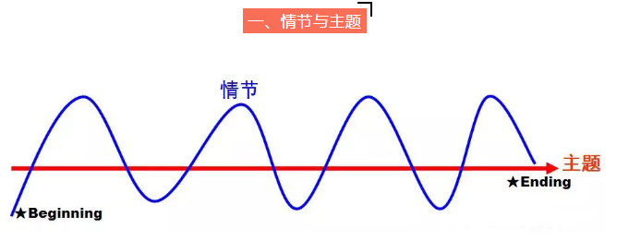

从图中可以看出，记叙文情节的发展总是一波三折，这可以借鉴语文作文教学中常常提到的：文似看山不喜平。意思是写文章好比观赏山峰那样，喜欢奇势迭出，最忌平坦。英文写作亦是如此，但不管情节如何一波三折，从开头到结尾，情节的发展总是紧紧围绕一个主题(或中心)在进行的。情节必须为主题服务，与主题无关的情节就是多余的内容。所以，首先要解决读的问题。通读原文，把握原文的主题是续后的第一步，情节的发展不能摆脱贯穿始终的主题。关于主题理解，你可以提出以下一些问题：

What does the author want to tell us?

What's the main idea of the passage?

What is the story about?

What is the theme revealed to you in the story?

What lesson can you learn from the story?

Can you predict how the story ends after reading it?

## 二、提示与结构

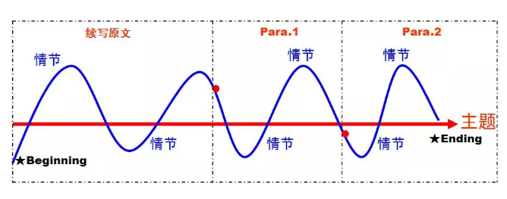从图中可见，续写在行文的衔接上分续写原文、Para.1与Para.2三个部分。在阅读原文，把握主题以后，接下来要根据Para.1与Para.2开头语的提示内容以及原文最后一段的情节，确定Para.1开头与结束可能出现的情节。因为无论情节如何起伏，思维如何开放，第一段的情节发展必须推向所要求出现的结尾部分内容。你可以这样问:

According to the given sentence of Para.2, what should be mentioned at the end of Para.1?

What is likely to happen according to the last  paragraph of the text and the the given sentence of Para.1?

同样，接下来要做的是根据Para.2开头语的提示内容以及文章的主题，确定第二段开头可能出现的情节以及结尾部分内容。做好这一步骤的好处是搭建文章结构，紧扣文章主题，不至于写到那时算那里。可以引导学生思考以下问题：

According to the given sentence of Para.2, what will happen next?

What should be mentioned at the end of the story?

What might be the ending of the story?

Do you think ending the story in this way satisfies readers?

## 三、Para.1细节

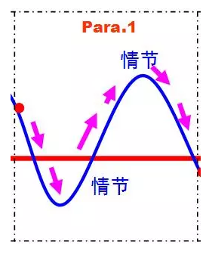



从图中可见，在确定Para.1开头与结束可能出现的情节以后，接下来要做的是确定组成情节发展的细节内容(details)。根据记叙文的特点，可以通过提问5W1H(who; what; when; where; which; how)6个方面的问题，身临其境，挑选紧扣文章主题并推动故事情节发展的细节内容，力求具体，不宽泛。前因推后果，前一句推动下一句。笼统地说，可以用以下问题打开思维，某人何时何地做了何事；怎样做；为什么这样做；出现了什么问题；看到了什么；听到了什么；说了什么；有什么感受；如何解决这一问题等等。当然，情节安排上要设立对立面，或者是冲突(conflict)，要有波折。但Para.1的情节发展最终要围绕主题指向第一段的结尾部分内容。所以，可以提出以下问题选择主要细节为我所用：

What did he/she do?

Why did he/she do...?

How did he/she do...?

What did he/she say about?

How did he/she feel...?

## 四、Para.2细节

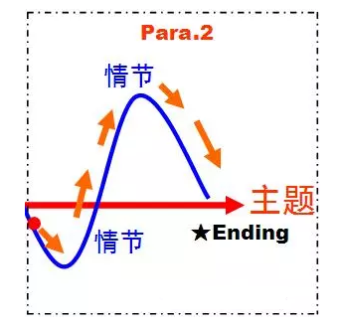



Para.2可以用Para.1一样的方法选择主要细节内容，这里不再表述。不同之处是情节发展到Para.2时，故事一般已进入高潮阶段，最后是问题得到解决，或者是表明一种看法或者是揭示一个主题。大体上会出现这样的模式：出现问题--解决问题--再次出现问题--终于解决问题--然后深有体会与感悟。如有可能，在结尾部分最好有与原文第一段的主题句相呼应的内容，起到点题的作用。

## 五、十个关键词

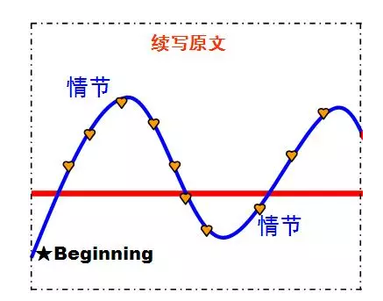

上面的心形代表的是续写原文所提供的10个划线关键词，10个关键词在一定程度上确定了情节发展的一些主要因素，包括了主要人物(main character)、主要地点(place)、主要事件(event)以及主要场景(sence)等。所以，我们可以通过分析10个划线关键词预测续写部分可能出现的情节，根据需要选择关键词。这一环节可以与前一步骤结合在一起，根据需要选择重要细节。以2016年10月浙江卷读后续写其中一个划线关键词语to her great joy为例，可以这样拓展学生的思维。

What made Jane feel so joyful?

In which paragraph will you use this phrase?

What did she do then in the situation like this?

将划线关键词放在最后考虑，目的是遵从“先整体，后细节；先宏观，后微观”的原则。这样做能确保“细节为主题服务”的思想，能最大限度的避免文不对题且言之无物的问题。

## 六、情节一览表

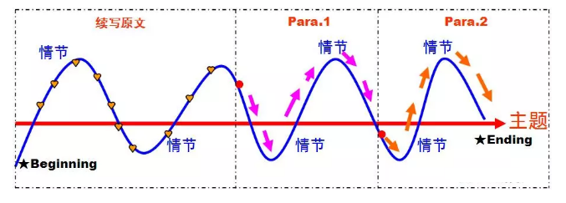一览表可以用课件的形式按步骤显现，下次如果你要对读后续写进行专题指导，可以根据该表帮助学生拓展思维，有效合理地扩展故事情节。

# 第二部分 情节推进的2种语言模式

**读后续写行为推进的2种模式。那么，对于这2类文体，有无对应的语言，答案是有的。经过长期的积累。总结出如下71种表达，希望大家好好琢磨哦。**

## 第一种模式：解决问题模式

**一、遇到问题**

Sb is confronted with a tough issue. 某人面临一个棘手的问题。

Sth is a tough nut to crack 某物是个需要解决的难题。

Sb scratches his/her head.

How… is beyond sb.

Sb is on pins and needles

Sb has ants on the pants

Stunned,sb is at a loss for words

Confronted with the tough nuts, the three friends were lost /sunk in thought.

Pondering over the matter, the three friends were lost /sunk in thought.

Cupping their faces in hand, the three friends sank into deep thought.

Jaw resting on his / her hand, sb sank into deep thought.

Walking/Shuttling/Wandering/Pacing back and forth, he was debating what to do next.

**二、想到办法**

Suddenly,an idea flashed across /popped into sb’s mind that

It suddenly occurred to /dawned on / hit / struck sb that

An idea occurred to / dawned on / hit/ struck sb that

**三、实施过程**

With everything in place, the three friends …

With all the preparation work under way, the three friends …

With XXX ready and XX in hand, the three friends …

With XXX in one hand and XX in the other,  the three friends …

**四、结果如何**

As it turned out/came out,

It turned out that …

Thankfully/Luckily/Fortunately,

Unfortunately/Unluckily,

Sth ended up …

Sth wound up …

Finally/Eventually /Ultimately, …

Sb heaved /let out a sigh of relief

What a  relief !

What a narrow escape

**五、抽象道理**

It is at this moment that sb realized …正是在这个时刻，某人意识到

It is not until … that sb …. 直到...那个人

Sth impresses on sb that … 这让某人印象深刻

It’s a life lesson inscribed in sb’s mind that … 这是一个生活课铭刻在某人的脑海中

It’s an invaluable lesson I kept till this day that … 这是我一直坚持到今天

## 第二种模式：纠结型模式

一、遇到问题

Sb is confronted with a tough issue

Sth is a tough nut to crack

Sb scratches his/her head.

How… is beyond sb.

Sb is on pins and needles

Sb has ants on the pants

Stunned,sb is at a loss for words

Confronted with the tough nuts, the three friends were lost /sunk in thought.

Pondering over the matter, the three friends were lost /sunk in thought.

Cupping their faces in hand, the three friends sank into deep thought.

Jaw resting on his / her hand, sb sank into deep thought.

Walking/Shuttling/Wandering/Pacing back and forth, he was debating what to do next.

二、**主人公思想斗争：正确观点与错误观点的交锋**

1. Caught in a dilemma, sb was at a loss what to do. 陷入困境，某人不知所措。

2. Sb is trapped/caught between A and B

3. Sb is standing at a crossroads as to … 某人正站在十字路口......

4. It seems two little men were fighting in his head. One was … The other was …

5. It seems two thoughts were having a tug of war. One was… The other was …

**三、主人公思想斗争：正确观点战胜了错误观点**

1.Finally, sb’s conscience triumphed over his/her evil thought 最后，某人的良心战胜了他/她的邪恶思想

2.Finally, good triumphed over evil. 最后，善良战胜了邪恶。

3.Finally, a clear conscience triumph over a guilty one. 最后，一个问心无愧的人战胜了一个有罪的人。

4.Finally, justice won over. 最后，正义获胜了。

5.Finally, honesty / integrity / fairness won over. 最后，诚信/诚信/公平胜出。

**四、采取了正确的行动**

1.sb decided to give sth back 某人决定把某物还回去

2.sb decided to do the right thing. 某人决定做正确的事。

3.Sb chose honesty over personal gain. 某人选择诚实而不是个人利益。

4.Sb chose integrity over personal interest. 某人选择诚信而不是个人利益。

5.sb finally stood on the side of integrity /honesty /fairness /justice. 某人终于站在正直/诚实/公平/正义的一边。

**五、抽象道理** (同第一种模式)

It is at this moment that sb realized …正是在这个时刻，某人意识到

It is not until … that sb …. 直到...那个人

Sth impresses on sb that … 这让某人印象深刻

It’s a life lesson inscribed in sb’s mind that … 这是一个生活课铭刻在某人的脑海中

It’s an invaluable lesson I kept till this day that … 这是我一直坚持到今天

# 读后续写真题实战

读后续写是新高考模式的一个重要的改革，这个题型对学生的读和写提出了更高的能力要求，学生要能够基于文章的理解用自己的语言对原文进行续写，想要写出一个情节逻辑合理，对老师和学生来说无疑是一个巨大的挑战。2020年真题为例，一步一步讲解分析。

## 原题材料

阅读下面短文，根据所给情节进行续写，使之构成一个完整的故事。

One fall, my wife Elli and I had a single goal: to photograph polar bears. We were staying at a research camp outside “the polar bear capital of the world” — the town of Churchill in Manitoba, Canada.

Taking pictures of polar bears is amazing but also dangerous. Polar bears — like all wild animals — should be photographed from a safe distance. When I’m face to face with a polar bear, I like it to be through a camera with a telephoto lens. But sometimes, that is easier said than done. This was one of those times.

As Elli and I cooked dinner, a young male polar bear who was playing in a nearby lake sniffed, and smelled our garlic bread.

The hungry bear followed his nose to our camp, which was surrounded by a high wire fence. He pulled and bit the wire. He stood on his back legs and pushed at the wooden fence posts.

Terrified, Elli and I tried all the bear defense actions we knew. We yelled at the bear, hit pots hard, and fired blank shotgun shells into the air. Sometimes loud noises like these will scare bears off. Not this polar bear though — he just kept trying to tear down the fence with his massive paws(爪子).

I radioed the camp manager for help. He told me a helicopter was on its way, but it would be 30 minutes before it arrived. Making the best of this close encounter(相遇), I took some pictures of the bear.

Elli and I feared the fence wouldn’t last through 30 more minutes of the bear’s punishment. The camp manager suggested I use pepper spray. The spray burns the bears’ eyes, but doesn’t hurt them. So I approached our uninvited guest slowly and, through the fence, sprayed him in the face. With an angry roar(吼叫), the bear ran to the lake to wash his eyes.

注意：

1. 所续写短文的词数应为150左右；

2. 至少使用5个短文中标有下划线的关键词语；

3. 续写部分分为两段，每段的开头语已为你写好；

4. 续写完成后，请用下划线标出你所使用的关键词语。

A few minutes later, the bear headed back to our camp.

At that very moment, the helicopter arrived.

## 

## 情节推进思路一

本文主要讲述了人与熊对抗，之后成功脱险的故事。主人公的感情线变化为：兴奋渴望→惊恐→放松。剧情线以主人公如何与北极熊周旋并成功摆脱它展开。

由第一段的段首提示句可知：几分钟后，熊又回到营地。接下来可通过场景渲染，描写当时令人颤栗惊恐的画面，例如“Roars and screams pierced the silence with needle-like shrillness.”这不仅合理地描写了熊的反应，也描绘出让人战栗的场景。

由第二段的段首提示句可知：此时，直升机到了。如果想要进行续写两段的合理衔接，第一段的结尾可描写成“After thoroughly scrutinizing the area, the bear trotted forward a few steps.”这样可以营造出危急的场景。“我们”看到直升机的到来，感到绝处逢生的喜悦，可以以人物心理描写作为第二段的开头，重点描写喜极而泣的状态，例如“My heart leaped with joy as I knew we were likely to be saved.”

最后，结尾部分需要迅速收束，并说明成功逃脱的结局。

关于画线词：Elli作为女主人公，是续写内容中应该出现的画线词，noises, pictures, fence, spray与熊有关，也在两段续写内容中出现。最终，两人回归安全状态，因此画线词safe也可自然而然地出现在续写内容中。由此划分画线词，可迅速锁定需使用的画线词范围，辅助构思。

A few minutes later, the bear headed back to our camp. Roars and screams pierced the silence with needle-like shrillness. The noises turned Elli and I pale with horror. I feared that the giant would destroy our whole fence. He roared repeatedly, shattering what was left of the silence. Elli seized this opportunity to take some pictures of the bear. The animal’s noises echoed all around us. We betrayed our feelings by huddling together, shivering with fear. After thoroughly scrutinizing the area, he trotted forward a few steps.

At that very moment, the helicopter arrived. My heart leaped with joy as I knew we were likely to be saved. Elli used pepper spray again to buy us enough time. But this time the bear became more alert. He regarded us with the merciless necessity of hunger, so we throw all the food we have. He then turned away and started devouring. As we were climbing the rope ladder, Elli prayed like a thousand times to show thankfulness of being safe and sound. (154词，21分)

## 情节推进思路二

由第一段的段首句可知，热爱摄影的“我”和妻子Elli处于危险之中——北极熊再次向他们靠近了，表明情况不容乐观。而第二段的首句明确了救援的直升机终于赶来，一切就此出现了转机。所以在构思时，越是将第一段写得危急，就越能与后面的转折形成鲜明对比，增加故事性。

因此，联系前文背景，续写第一段可以先描写熊的动向和作者的心理，之后描写作者的应对举措。由前文和段首句分析可知，胡椒喷雾并未阻挡熊继续靠近，反而激怒了它。而“我”作为摄影师，看到拍摄对象不断进入自己的取景范围不禁想要立刻实现梦想去拍摄，然而求生的本能让“我”无暇他顾。后面采取的措施可以是作者急中生智，决定和妻子把面包给熊来拖延时间等待救援。而眼看着可怕的熊在不断靠近，面包也即将耗尽。至此，作者夫妇二人几乎陷入绝境。这一部分可以进行生动的描写让作者的心理刻画更为生动，例如“While it was looming like a dark cloud...”。

第二段首，直升飞机抵达，至此，可以进一步渲染危急的场景，继续描写熊的动作，例如猛击栅栏。在描写完二人获救后，结尾呼应前文，作者一路有惊无险，成功用相机拍到梦寐以求的照片，不虚此行。

关于画线词：Elli作为女主人公，是续写内容中应该出现的画线词，除此以外，spray的提及可呼应前文，交代故事发展，photograph, camera可以直接呼应“我”采取的一些行动，bread是我们想到的解决方案，fence与熊相关。由此展开画线词，保证了故事的合理性。

A few minutes later, the bear headed back to our camp. He could not resist the temptation of the bread. The pepper spray had slowed the bear but wasn’t enough to stop the beast. On the contrary, it provoked the bear and made him even more furious. Much as I wanted to photograph the approaching bear, my survival instinct overtook my desire to capture the perfect photo. In a moment of panic, Elli and I decided to give him what he wanted — the garlic bread. While it was looming like a dark cloud, we threw the bread at the bear a little bit at a time until it had run out.

At that very moment, the helicopter arrived. But the irritated bear has already started to whack the fence. I feared that the bear would tear down the fence at any minute. Luckily, the rangers came to our rescue. They managed to calm the bear down and distract him with some sort of acoustics. Even though my heart was still thumping wildly inside my chest, I snatched my camera and snapped one last shot of the bear, a photo that I had always longed to capture. Though risking my life, I’ve got the best picture ever and it’s all worth it. (200词，22分)

## 情节推进思路三

续写两段中，故事的剧情在第一段结尾达到高潮，之后开始回落；可以推测主人公的情绪呈现出紧张→惊恐→松一口气→彻底放松的变化。

第一段北极熊返回后，可以通过熊的新一轮进攻引出剧情，随着熊的攻击愈发猛烈，主人公需要采取新方法避险。例如，可以描写熊再次攻击栅栏，“我”如何使用随身物品应对进攻，保护自己和妻子的安全。同时也可以描写妻子的动作和情绪，烘托场面的危急。通过“我”与熊的动作交替，在第一段最后一句将人与熊的矛盾推至最大。

第二段直升机到来后，可以描写“我”避险的动作，例如立刻调转方向跑回营地。之后利用直升机的优势解决问题，如利用螺旋桨发出的巨大声响吓退经验不足的北极熊。结尾处呼应开头，总结作者此行的目的是否达成。

关于画线词：Elli作为女主人公，是续写内容中应该出现的画线词，除此以外，fence的描写与熊相关，“我”用camera进行攻击防身，以达到safe的目的，动作描写包含run，危机时刻直升飞机的noises保证了可以击退熊，最终提及pictures呼应此行目的。由此展开画线词，布局合理自然，符合故事逻辑。

A few minutes later, the bear headed back to our camp. The furry giant must have gathered his wits, for he suddenly reared up and attacked the fence with ferocious strength, leaving a narrow opening on it. Behind me, Elli muffled a cry of terror. My eyes were fixed on the intruder. My mind raced like flash as my hands groped for anything that might keep us safe from the bear’s rampage. That’s when I felt the camera. With little hesitation, I shoved the equipment through the opening as the polar bear closed his jaws on the lens and then pulled my whole camera out and smashed it.

At that very moment, the helicopter arrived. I ran back to the camp, stumbling a hundred times in my haste. Elli contacted the pilot over the radio. Hearing that we had not suffered any physical injury, the pilot told us to stay put and cover our ears. The harsh whooshing noise of the approaching helicopter spooked the young bear. The animal took a few hesitant steps back and eventually disappeared back towards the lake. Although my camera has met its glorious end, and though all our pictures were lost, our memory of this unexpected encounter remains fresh till this day. (187词，23分)

**02出彩表达积累**

单词

sniff v. 嗅；闻 massive adj. 巨大的

encounter n. 遭遇；邂逅 roar v. 吼叫，咆哮

shatter v. (使)破碎，破裂 huddle v. 挤在一起，缩成一团

scrutinize v. 仔细查看 trot v. 碎步急行

regard v. 注意，关注 devour v. (尤指因饥饿而)狼吞虎咽地吃光

provoke v. 激怒 furious adj. 狂怒的

instinct n. 本能，直觉 irritate v. 使烦恼(尤指不断重复的事情)

ranger n. 护林员 distract v. 转移(注意力)

thump v. 怦怦地跳 snap v. 拍照

furry adj. 覆盖着毛皮的 wits n. 机智，智慧

ferocious adj. 凶猛的 muffle v. 压抑(声音)

intruder n. 侵入者 grope v. 摸索

rampage n. 暴跳如雷 shove v. 猛推

jaw n. 颌骨 stumble v. 跌跌撞撞地走

haste n. 急忙，仓促 harsh adj. 刺耳的

whoosh v. 发出嘶嘶声 spook v. 惊吓

smash v. 打碎

**短语**

face to face 面对面 scare...off 吓跑

tear down 拆毁 pull out 拔出

rear up 用后腿站立

句子It is easier said than done. 说起来容易，做起来难。(谚语表达)

Terrified, Elli and I tried all the bear defense actions we knew. 在惊恐万分的情况下，埃利和我尝试了我们所知道的所有应对熊的防卫措施。(过去分词做状语)

He stood on his back legs and pushed at the wooden fence posts. 他用后腿站立，推着木栅栏的柱子。(动作的生动描写)

Roars and screams pierced the silence with needle-like shrillness. 吼叫声和尖叫声打破寂静，尖锐刺耳，久久未消。(环境的生动描写)

We betrayed our feelings by huddling together, shivering with fear. 我们紧紧地抱在一起，害怕地直打哆嗦。(动作的生动描写)

After thoroughly scrutinizing the area, the bear trotted forward a few steps. 在仔细地观察了这片区域之后，熊向前小跑了几步。(动作的生动描写)

While it was looming like a dark cloud, we threw the bread at the bear a little bit at a time until it had run out. 熊像噩梦般一直萦绕着我们，我们一点点地向它投着面包，直到面包也没有了。(比喻的生动描写)

I snatched my camera and snapped one last shot of the bear. 我抓起相机，拍下了最后一张熊的照片。(动作的生动描写)

My mind raced like flash as my hands groped for anything that might keep us safe from the bear’s rampage. 我的头脑像闪电一样飞速运转着，我的双手摸索着寻找能让我们自保的东西，免遭毒手于熊的暴怒之下。(比喻的生动描写)

I ran back to the camp, stumbling a hundred times in my haste. 我跑回了营地，匆匆忙忙，期间跌倒了无数次。(夸张的生动描写)